Collection Soft Link – Detailed Design

This document provides impact analysis of the DME functionalities needed to be updated in order to support a soft linked collection.

DME Features – specific handling / logic for linked collection
The following DME features will need to be modified to be aware of a linked collection and implement specific logic –
- Delete collection – delete the collection itself but don’t delete ‘collection listing entries’. Error if requested to do so
- Migrate collection – don’t allow – deny the request
- Download collection – download the ‘collection listing entries’ of the linked collection
- Tier collection – don’t allow – deny the request
- Browse collection – show the ‘collection listing entries’ of the linked collection

Detailed Impact Analysis

Get Collection Services in HpcDataManagementService
We have 4 flavors of ‘get collection’ services. In all of them the service returns data about the collection itself and data about ‘collection listing entries’ (sub collections and data objects under this collection).

These 4 services will need to be updated to account for a soft link collection, in which the data about the ‘collection listing entries’ needs to be obtained from the linked collection.

The 4 services are

/**
* Get collection by its path.
*
* @param path The collection's path.
* @param list An indicator to list sub-collections and data-objects.
* @return A collection.
* @throws HpcException on service failure.
*/
public HpcCollection getCollection(String path, boolean list) throws HpcException;

/**
* Get collection by its path and all sub-collection and data objects list
*
* @param path The collection's path.
* @return A collection.
* @throws HpcException on service failure.
*/
public HpcCollection getFullCollection(String path) throws HpcException;

/**
* Get collection children by its path. No collection metadata is returned.
*
* @param path The collection's path.
* @return A collection.
* @throws HpcException on service failure.
*/
public HpcCollection getCollectionChildren(String path) throws HpcException;

/**
* Get collection children by its path starting at user specified offset.
*
* @param path The collection's path.
* @param offset The offset to start.
* @return A collection.
* @throws HpcException on service failure.
*/
public HpcCollection getCollectionChildrenWithPaging(String path, Integer offset) throws HpcException;

These 4 services will need to be update to account for a soft link collection, in which the data about the ‘collection listing entries’ needs to be obtained from the linked collection.

Get Collection Services Usage Summary
All the DME code that is using the 4 methods above will need to update and incorporate logic for linked collections as needed.

Note that some usage of these services is to simply validate if a collection exist. We can use this opportunity to do a small refactor and create a separate method to detect collection existence, so the code is not impacted by linked collection.

getCollection()
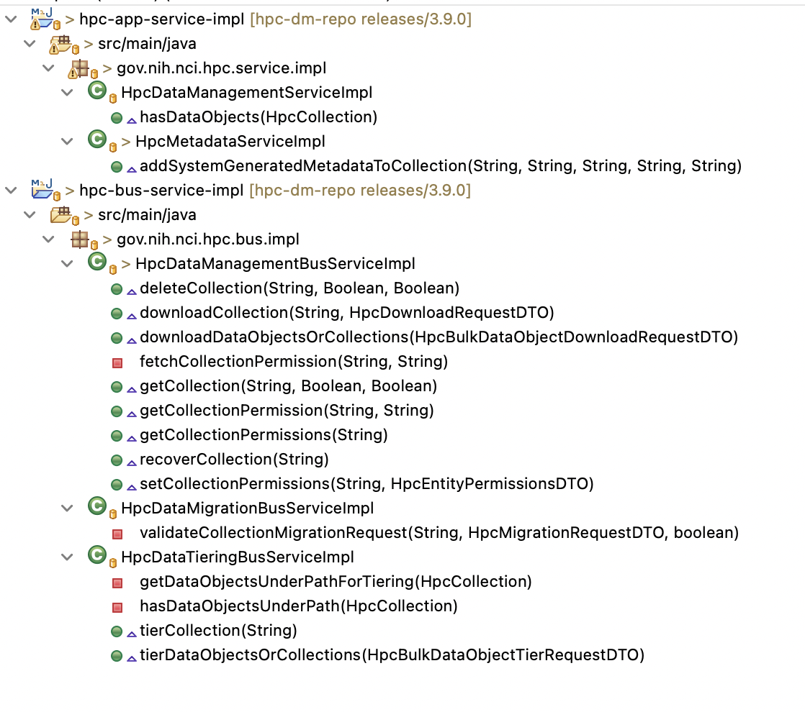

getFullCollection()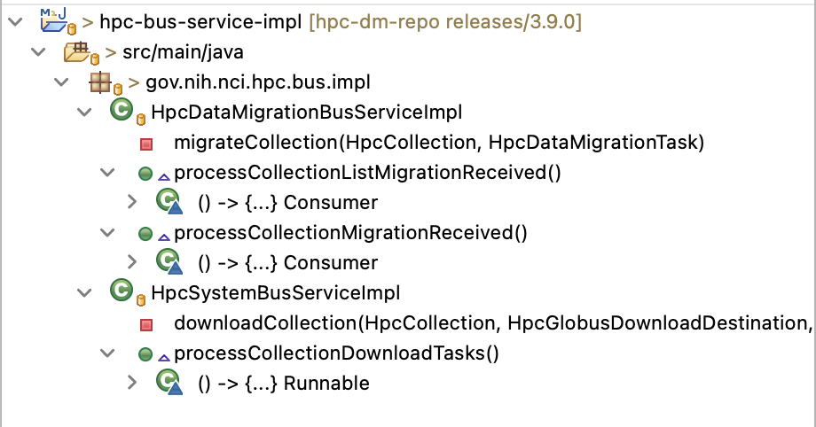

getCollectionChildren()
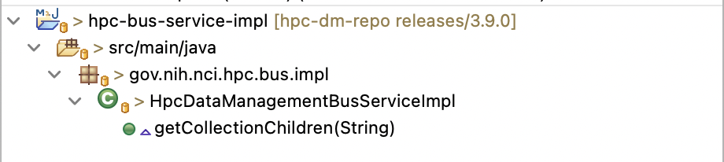

getCollectionChildrenWithPaging()
